Factor 1 Racing, Inc.
805 West Freeport Street
Broken Arrow, OK 74012
Telephone (918)258-7223

jim@factor1racing.com | phil@factor1racing.com | sharrie@factor1racing.com
Chain Tensioner Installation Guide
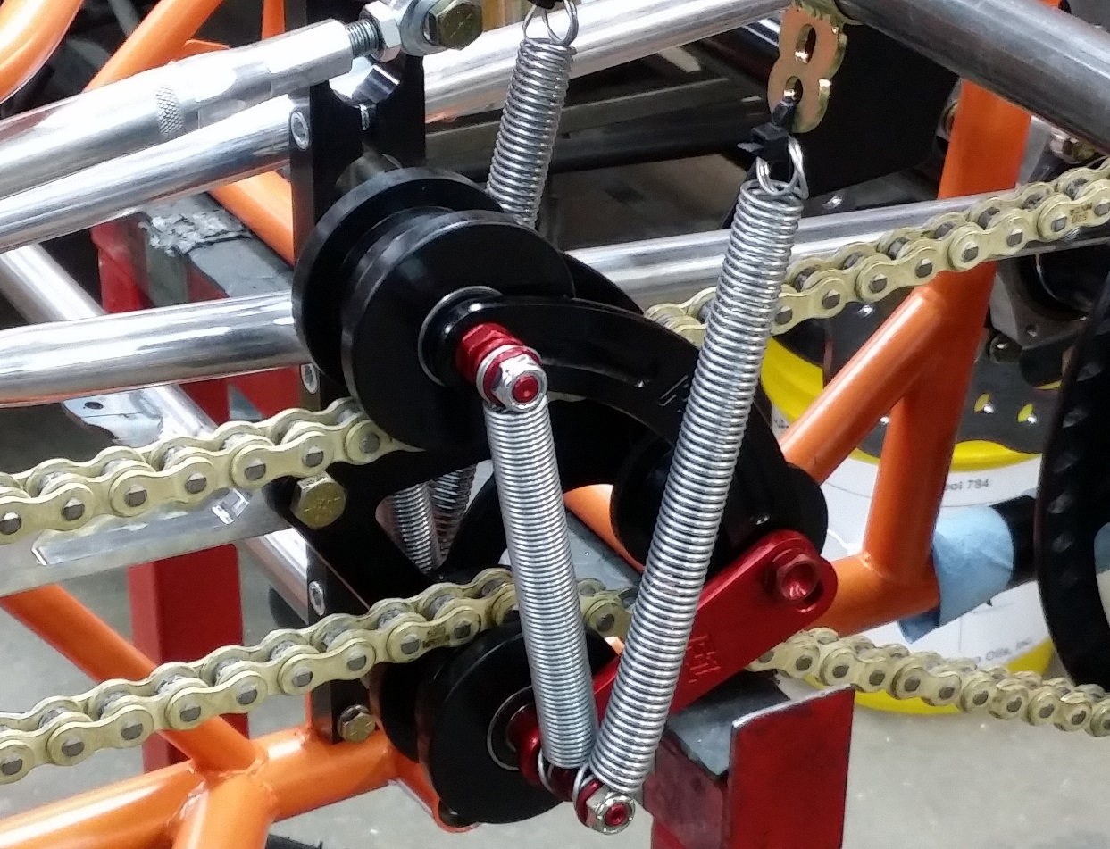

Setup

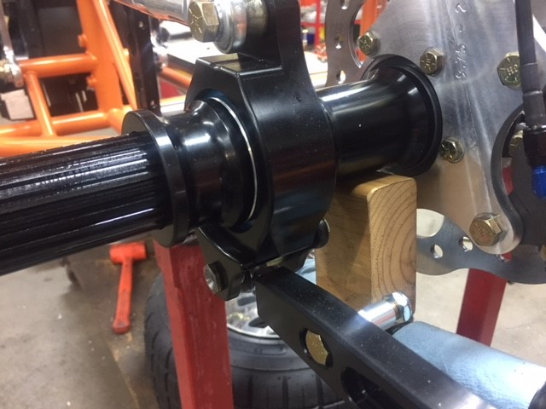
- Insert your rear set-up blocks between the rear axle and lower frame rails.
Figure 1
Axel suspended by set-up block
- If chain is not removed, remove chain.
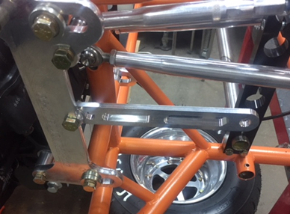
- Install bolt to secure the center attachment arm onto the engine mount. The three holes on the attachment arm are used to obtain proper spring angle. Start with the middle hole, as you may have to adjust later.
Figure 2
Attachment mounted to engine plate
Chain Length

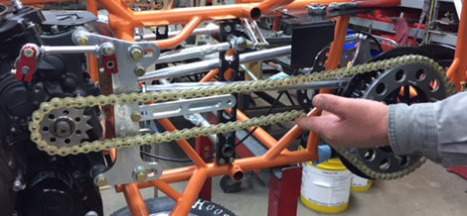
- With the engine shifted all the way to the rear of the car, mock the chain up. Adjust the chain so that the top and bottom of the chain parallel to each other all the way back to where the tensioner will be, as shown in Figure 3. To find the correct length for the chain, use zip ties attached to the sprocket to hold the overlapped chain links. The overlapped chain links are the ones that need to be remove.
Figure 3
Top and bottom of chain parallel back to tensioner
Figure 4
Excess chain links fastened with zip ties
- With the chain successfully mocked up, cut the excess links and install the master link.

Fit Check

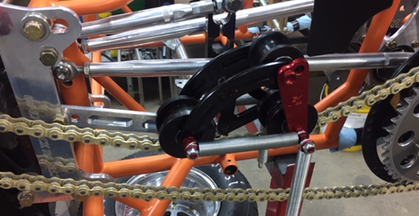
- Turn the tensioner over until the grooves in the large rollers are both facing down. Set the 2 grooved rollers so the grooves are centered on the chain. It will sit there by itself.
Figure 5
Tensioner assembly sitting on rollers
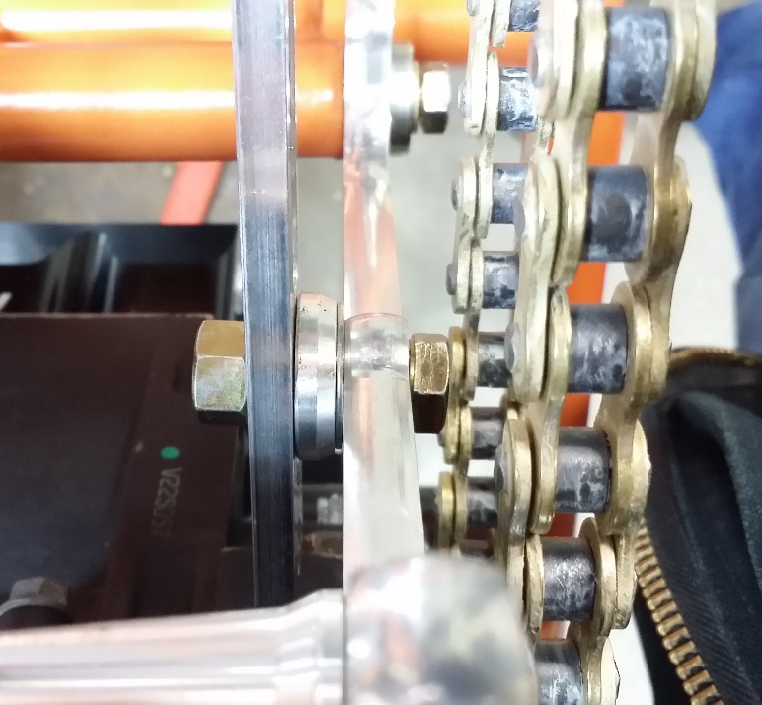
- Visually inspect the gap between the attachment arm and the tensioner. Add spacers between the attachment arm and the engine plate to allow the attachment arm and tensioner to be in line. The arm should just be in contact with the tensioner to allow the tensioner to be centered on the chain.
Attachment arm
Engine plate
Figure 6
Top down view of attachment arm spaced away from engine plate

- After the tensioner is correctly spaced, bolt the attachment arm to the tensioner.
Figure 7
Tensioner assembly sitting on chain with attachment arm mounted
Install Chain

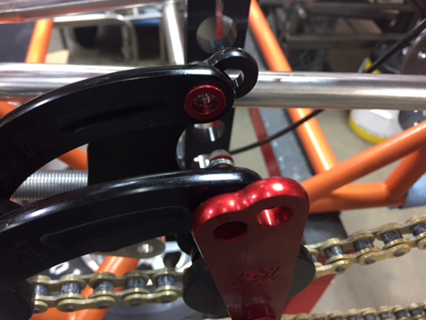
- Remove the lock nut from the center roller pin and remove the pin and center roller. Nothing should fall out.
Figure 8
Center roller and pin removed

- Insert chain between the upper and lower rollers. This can be done by separating the chain, or removing the front sprocket and threading it through the tensioner as shown.
Figure 9
Sprocket and chain threaded through tensioner rollers
- Reattach master link or bolt on front sprocket.

Fine Tune
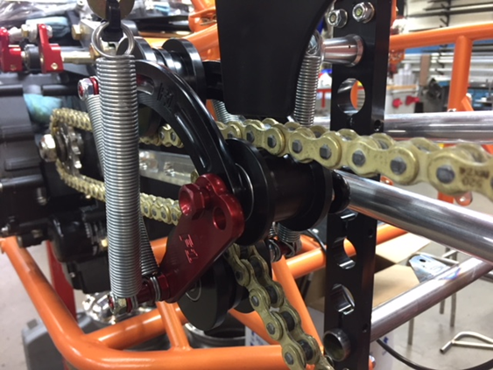
- Reinstall the center roller pin and roller.
Figure 10
Center roller reinstalled
- Install spring hangers by sliding them onto the end of the nerf bar and fasten the springs to the hangers with zip ties.
Figure 11
Spring hangers mounted and springs mounted to hangers

- Check the spring angle. The ideal angle is between 15-20 degrees. To change the angle, change the hole the attachment arm is mounted to the engine plate through. To increase the angle, shorten the attachment arm, to decrease the angle, lengthen the attachment arm. If the center roller is touching the top of the chain, the chain is too loose. Note this for the next step.
Figure 12
Attachment arm shortened giving acceptable spring angle

Chain Tension
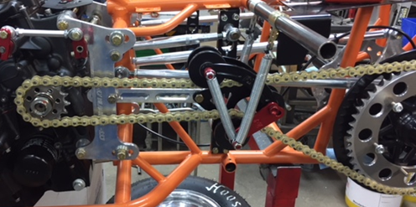
- A good place to start is with the top and bottom of the chain running parallel to each other back to the tensioner. However, the size of your front sprocket will affect things. Here, there is a 15-tooth counter sprocket, so the chain spacing should be a little closer together at the tensioner.
Figure 13
Chain a little closer than parallel at tensioner due to larger front sprocket
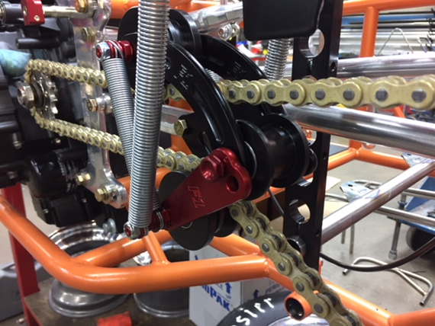
- Since the center roller was touching the top of the chain, tighten the chain. As the chain is tightened, check that the center roller is moving away from the top of the chain and toward the bottom.
Figure 14
Center roller moved towards bottom of chain by tightening chain

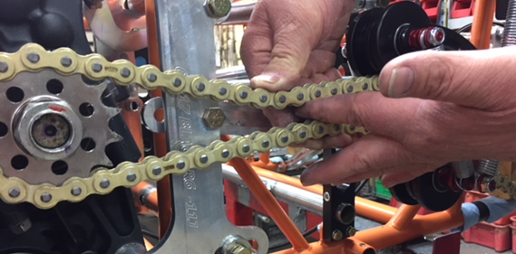
- With a 15-T counter sprocket, if you squeeze the chain together ahead of the tensioner, you should have about one finger or ¾” width between the top and bottom of the chain. With a 12 and 13-T counter sprocket, the top and bottom of the chain can almost touch.
Figure 15
Acceptable tension for 15 tooth front sprocket

